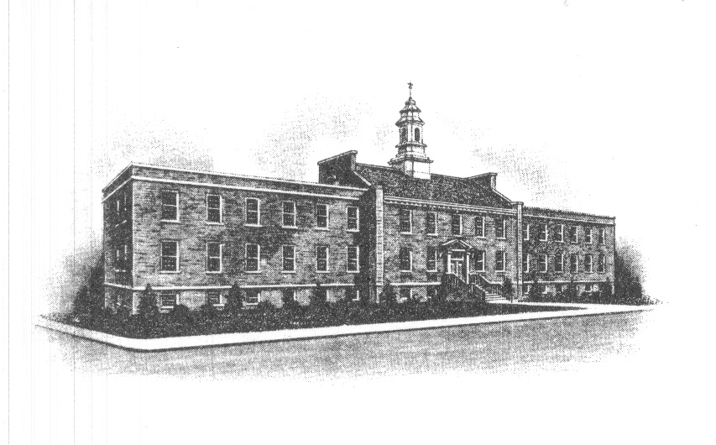
The Borough of Sayreville
Sayreville Board of Adjustment
167 Main Street
Sayreville, NJ 08872
(732) 390-7077 - Phone
(732) 390-7458 - Fax

ZONING BOARD MEETING CANCELLATION ANNOUNCEMENT

Take notice that the regularly scheduled meeting for February 23, 2022, of the Zoning Board of Adjustment in the Borough of Sayreville, N.J. has been cancelled, and the Board accepts jurisdiction of the following applications:

Case No. | Applicant | Location | Application
22-03 | Kearon Gregory | 22 Grand St. | Bulk Variance/Fence
21-23 | Muphy Lopez | 1094 Bordentown Ave. | Bulk Variance/Pool/Deck/  Patio/Driveway/Addition

and adjourns them, without need for further notice to the public, to the next meeting which will take place on March 23, 2022 at 7:30 PM at which time these applications will be heard in the Council Chambers in Borough Hall, 167 Main Street, Sayreville, NJ 08872.

Notice of the March 23, 2022 meeting will be posted on the Borough Website and on the bulletin board in Borough Hall, and noticed in The Home News Tribune. All applications, plans and documents related to the application(s) on the posted agenda will be available for review on the Borough website (www.sayreville.com) and in the Construction/Zoning Office located at 49 Dolan Street, Sayreville, NJ during normal working hours 7:30 AM – 3:30 PM by contacting Joan M. Kemble, Board Secretary at 732-390-7077.

Joan M. Kemble
Secretary
Zoning Board of Adjustment

